**Joint Pin Analysis**

One major area of concern for the proposed design was its printed joint pins. Printing plastic joint pins, rather than inserting metal ones, would allow for the design to be produced in one piece, making it a non-assembly model. This would drastically cut down on time and training required to create prosthetic hands, as well as differentiate the design from existing open-source devices.

Joint pins made this way would obviously be weaker than metal pins but given the hand’s purpose, for performance of everyday activities, and the strength of the motors and actuators involved, there is no real reason to seek out the extra strength of metal pins if plastic turns out to be adequate (as even in the case of impact most of the force would be distributed around the joint interfaces, not within the pins). To assess strength of the pins, a model was created in OpenSCAD and was then imported into SolidWorks for analysis.

The model generated was considered a “rough draft”, modeling only the middle (longest) finger, with correct finger segment lengths, hinge placements, and joint pin sizes. This model did not include the final iteration of the cable guides, nor various aesthetic features (to be added in later).

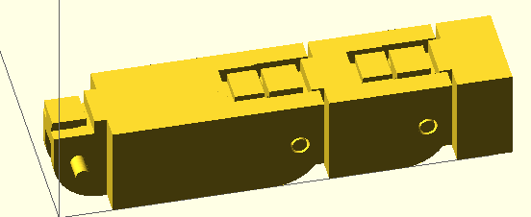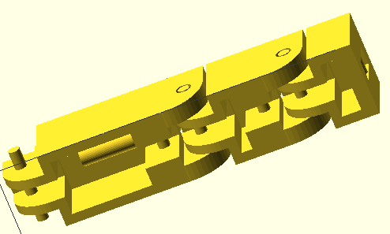

**Figure XXX: Base Finger Model. Top view (left) and bottom view (right)**

This model was then exported as three separate .stl files (one for the fingertip segment, one for the fingermid segment, one for the fingerbase segment), the geometry was fixed using Netfabb’s online cloud service, and it was imported into SolidWorks (using the “solid body” condition). Once in SolidWorks a few changes had to be made to get it to run with SolidWorks’ solvers. First it was run through SolidWorks’ import diagnostics (basically an inbuilt geometry fixer) and then it was converted to SolidWorks features using the FeatureWorks “Recognize Features” option. A force analysis could be performed on the finger segments once all of this was completed.

The force analysis was first run on the fingertip, with force applied at the bar where the driving cable would be tied. Force was defined as 4.5 Newtons, the maximum torque of the selected servo motor. The joint pins were defined as fixed geometry since pulling the wire inward would grind the joint pins against the joint pin holes of the next segment.

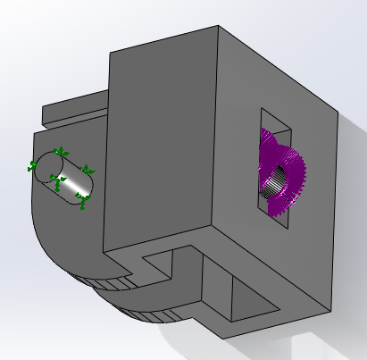

**Figure XXX: Force application at the fingertip. The purple arrows show where force is applied (along the front, top, and bottom portions of the bar) and the green arrows show fixed geometry (the joint pins).**

This analysis was performed first using ABS plastic as the material. This material was available from the SolidWorks library but yield strength had to be sourced elsewhere. **(Source 1)**

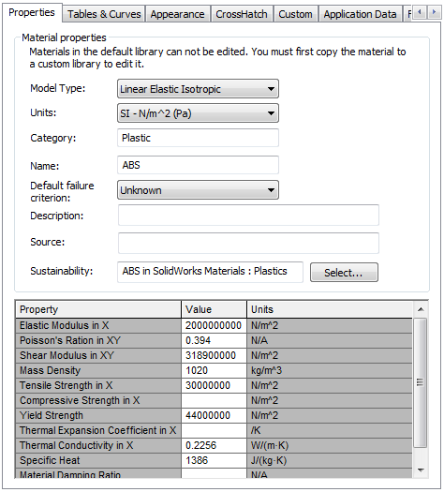

**Figure XXX: ABS material properties used.**

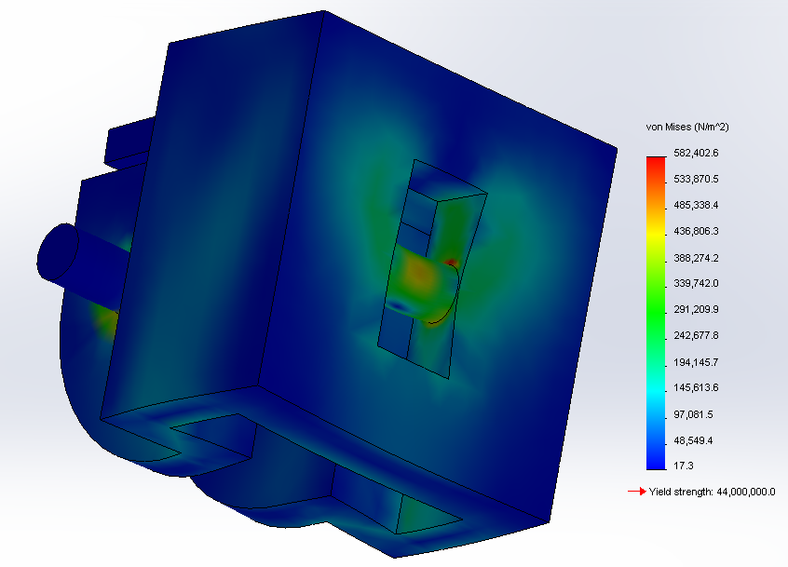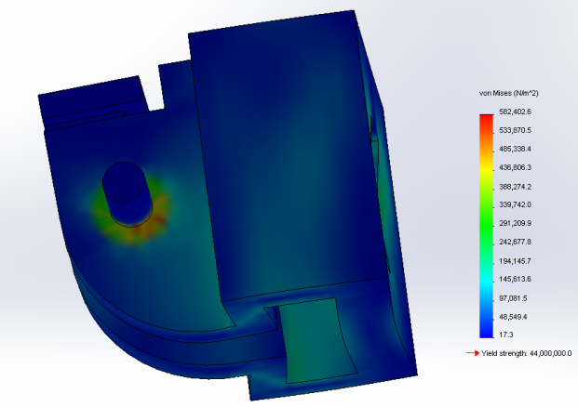Running the analysis showed that ABS passed these standard working conditions requirements with flying colors. Maximum stress in the segment was found to be 0.58 MPa, concentrated around the base of the joint pins (as expected). “Failure” was defined as reaching the yield strength of ABS plastic (44 MPa) since any force large enough to cause plastic deformation of the pins would prevent them from rolling properly in their joints. This yielded a factor of safety of 75.5 for the fingertip segment.

**Figure XXX: Views showing Von Mises stress and deformation at the connection bar (left) and at the joint pins (right). Note that deformation is greatly exaggerated (scaled up by a factor of about 450) in order to be visible.**

This analysis was then repeated for the middle and base finger segments. For these segments the force application was along the bottom and back of the joint holes and along the front and top of the wire guide. The joint pins were again defined as fixed points. The force was defined as 4.5 Newtons, spread evenly over points of contact.

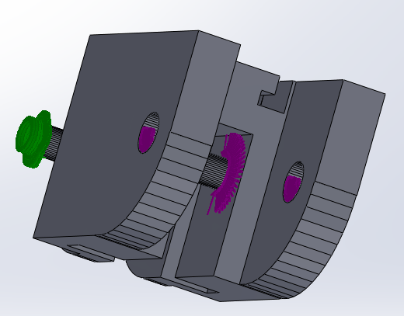

**Figure XXX: Force application at the middle segment. The purple arrows show where force is applied (the joint interface and wire guide) and the green arrows show fixed geometry (the joint pins).**

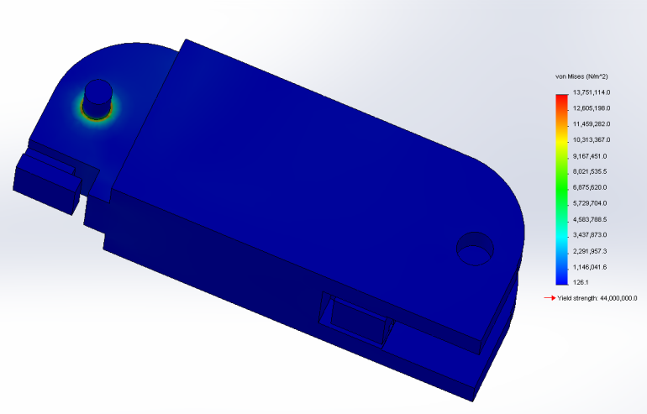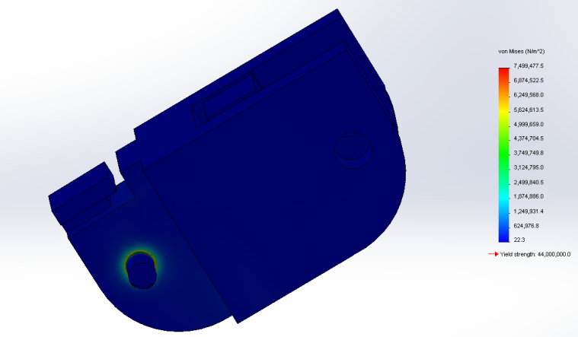**Figure XXX: Middle (left) and base (right) segment Von Mises stresses, showing that stresses are again concentrated at the base of the joint pins.**

Maximum stress was found to be 7.5 MPa for the middle segment and 13.8 MPa for the base. This yielded an overall factor of safety of 3.2, more than reasonable (especially when considering that the force will probably be more distributed when the hand is actually used—the simulation assumes that motor force is applied equally to each finger segment and that each segment receives maximum possible force).

Since the joint pin analysis showed that ABS passed use cases, the idea of printing in polycarbonate plastic could be eliminated, since the extra strength would not be necessary for the scope of the project. This eliminates a great deal of cost and complexity. Additionally, since ABS proved more than adequate, PLA (a weaker plastic) was also tested (PLA is more environmentally friendly than ABS, being made entirely from plant material, and releases no toxic fumes while printing). PLA was not included in the Solidworks Materials Library, so a new material had to be defined. Values were obtained from **(Source 2)** and **(Source 3).**

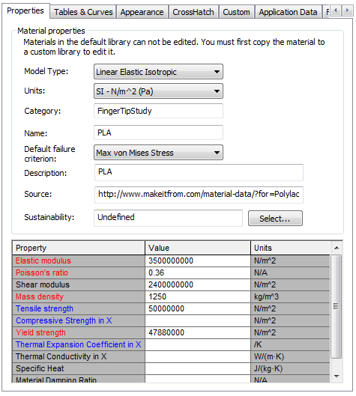

**Figure XXX: PLA material properties used.**

Running the joint pin analysis with PLA showed that maximum stress during working conditions occurred at the base segment again and totaled 13.8 MPa, yielding a factor of safety of 3.5 (as yield stress of PLA is 47.8 MPa). This meant that under working conditions both materials were completely suitable.

In an attempt to differentiate more between PLA and ABS plastics, a test of ultimate strength was performed. For this load to failure test, the base segment was modeled as if the finger was being bent backward.

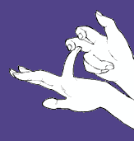

**Figure XXX: Failure testing scenario. (Source 4)**

This model only examined the joint pins at the base of the finger, since that is where the most force would be concentrated (due to the rest of the finger acting as a moment arm). Two tests were run: a worst case scenario (where all force was transmitted to the joint pins) and a realistic scenario (where force was transmitted to the joint pins and at the top edge of the joint). Force was applied the same way as for the standard use models, and was steadily increased until yield failure occurred.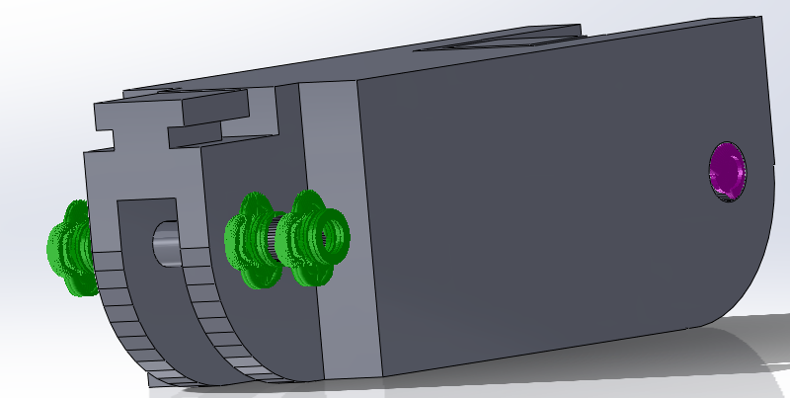 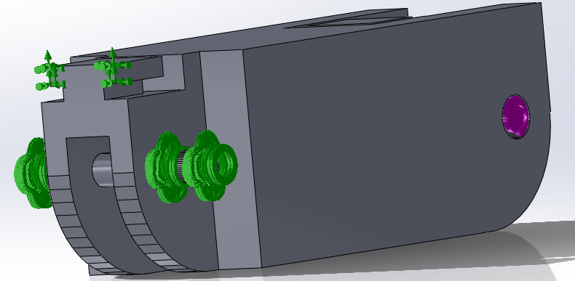

**Figure XXX: Worst case (left) and realistic (right) diagrams of force application (purple) and fixed position (green).**

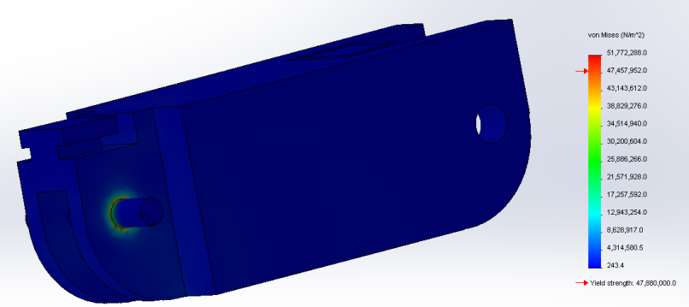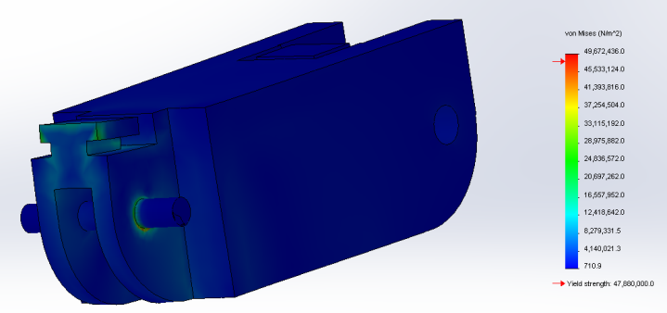In the worst case scenario, both materials failed at just under 15 Newtons. While this value is fairly low, in the realistic scenario, ABS failed at about 40 Newtons, and PLA failed at about 43 Newtons, which was much more reasonable. Therefore the load-to-failure test found that both materials were comparable (and that either way the finger wouldn’t be too fragile).

**Figure XXX: Worst case (left) and realistic (right) stress distributions.**

Therefore, the conclusion for the joint pin analysis was that polycarbonate plastic could be eliminated from the design, both PLA and ABS plastics would be mechanically suitable for the final design (though ABS may be a better choice due to impact resistance and wear issues), and that the printed joint pins were a completely viable choice (at least in respect to forces incurred under working conditions and force required for failure), and would not need to be replaced with metal ones.

**Printed joint pins**

However, while the joint pin analysis found the pins mechanically viable, there was still one major design issue with them. The joint pins must “float” in midair during printing, they are small features, with relatively high tolerance, requiring the 3D printer to lay filament with no support material.

Typically when 3D printers must print overhangs more than 45 degrees, they must lay out support material to prevent the filament from sagging. Usually this just consists of fragile layers that are designed to break off easily, but inside the finger joints there is not enough space to clean these out. The other type of support material is sacrificial material, a different material from the structure, one with different chemical properties that will dissolve in water or a weak acid/base. While it is reasonable to design with sacrificial material in commercial 3D printers, for small-scale printers like the ones our target users will own, it is not common. Most consumer 3D printers only have one extruder (though dual extruder models, capable of laying down sacrificial material, do exist).

Therefore, if the joint pins are too large to print as overhanging geometry, with no support material, then they will not be suitable for the final product (despite working quite well in the force analysis). However, part of the draw of 3D printing is that material is extremely cheap and readily accessible, and that manufacture requires almost no labor. This means that a project like this one can be printed at an early stage, dealing with many manufacturing issues early on. Therefore, the best test of print viability is to actually print the finger.

The finger was first printed on a PrintrBot Plus. The print weighed 27 grams in total, and used about 84 cents worth of material. It only took 30 minutes to complete print of one finger, which was well within reasonable time constraint for prosthetic manufacture—it is reasonable to assume that one prosthetic should be around a 20 hour print.

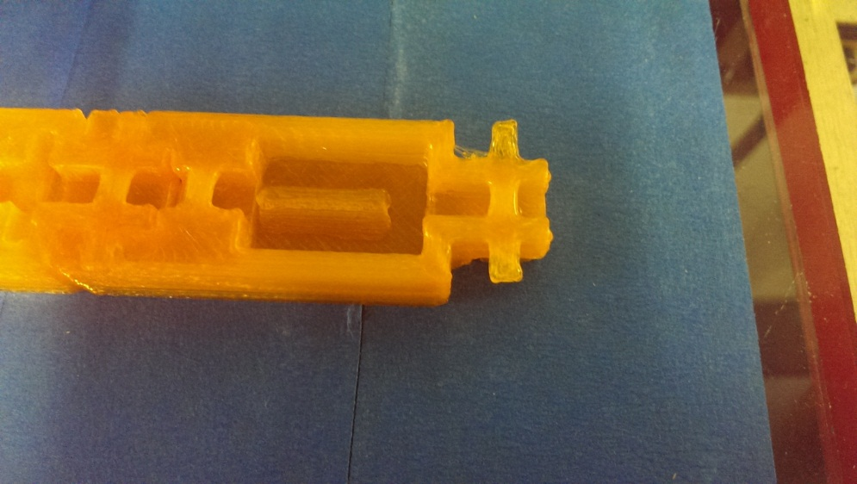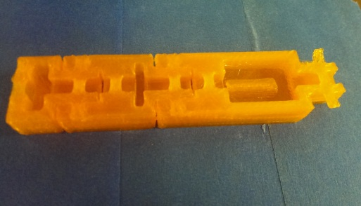The first print was a failure, which should be expected given how much calibration and iteration 3D printing generally requires. The way that it had failed was that the tolerances at joint interface was set too low, causing the segments to bridge together and making a completely rigid structure (tolerance at the joint interface was set to 0.5 mm, well above the 0.04 mm that the printer should be capable of, but of course given how consumer 3D printers are an emerging technology they are not always consistent). The joint pins suffered from the same issue, bridging the gap between themselves and the joint pin holes. Though it was hard to see from the first model, the pins also appeared to be too warped for the design to function.

**Figure XXX: Points of failure: The joint pins (left) are definitely too rough for a plastic-on-plastic joint interface. Joint tolerance (right) is too low, plastic has bridged the points of articulation and the finger is solid.**

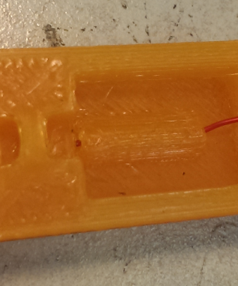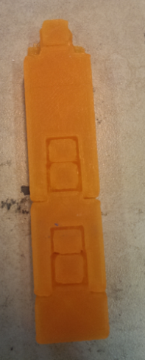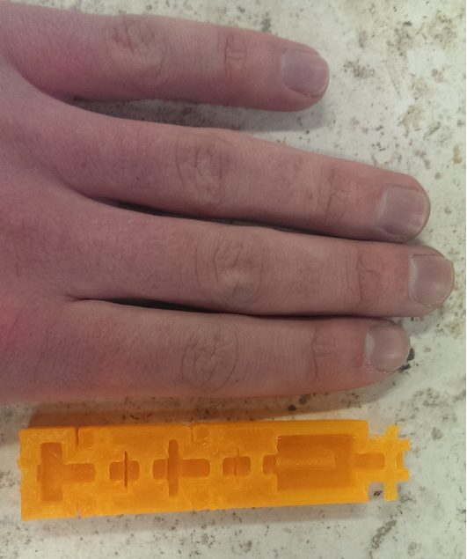Positive points of the initial print were also identified. Aside from the required tolerance adjustments, the rubber band guides (which also have slight overhangs) printed successfully, scaling was perfect (exactly the proportions of a human finger) and other small features, such as the wire guide, printed properly.

**Figure XXX: Positive points: the scaling (left), rubber band guides (center) and wire guides (right) are all correct and functional.**

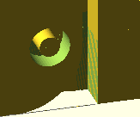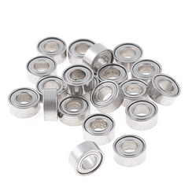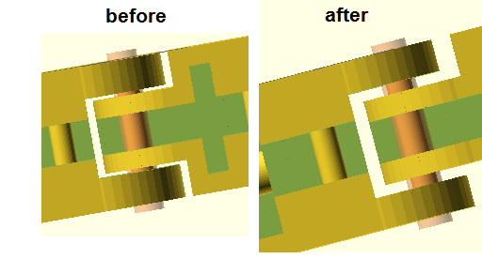Based on these initial findings it should be completely reasonable to use 3D printing as the method of manufacture provided that the joint clearances and joint pin clearances were larger. The model was then modified for these new adjustments. Joint clearance was greatly increased, and bearings were added to the design to solve both the problems of joint pin clearance and joint pin warpage in one step. Since these plastics are designed to be melted and extruded, they are obviously very pliable when hot. Therefore, by making large joint holes suitable for accommodating a bearing, and then applying a heatgun briefly before pressing the bearing into the space, a 2mm printer clearance can be added, solving the bridging problem, and the joint pin has been forced into the bearing hole, solving the slight warping issue.

**Figure XXX: Left to right: Improved joint clearances, bearings, bearing clearance. Bearing source image: (source 5)**

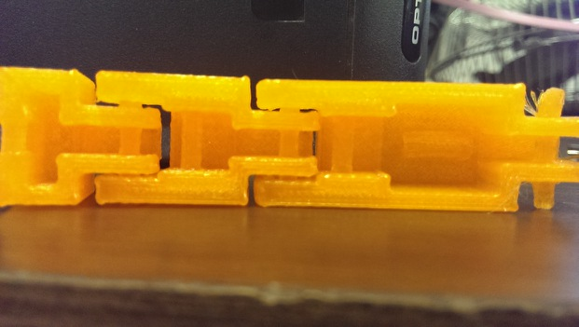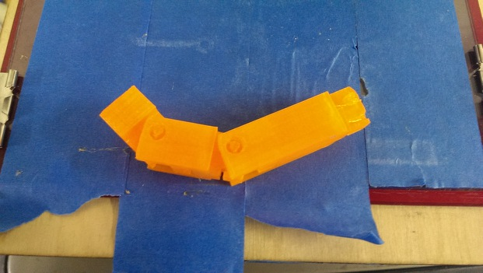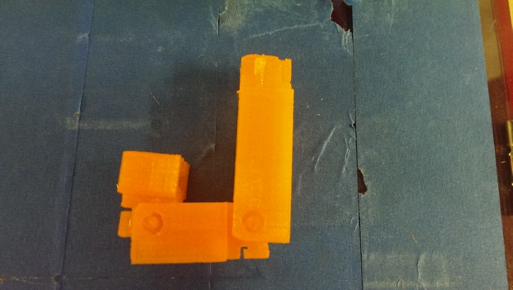After these changes were made, another test print was performed, showing that the changes had fixed all manufacturing issues. Increasing the tolerance had prevented the joints from fusing and the extra space for the bearings had prevented the joint pins from failing.

**Figure XXX: Joints are now functional and joint pin problem has been solved.**

The conclusion from this manufacturability analysis is that the finger can be printed as a non-assembly model so long as tolerances are made large enough, and so long that measures can be taken to prevent excessive warping in the joint pins. Without bearings, the finger is perfectly functional although it does tend to rattle. It can even be possible to add bearings on a case-by-case basis, where hands with relatively non-warped pins can be provided as-is, and those with slight defects can be corrected with bearings. Regardless, there seems to be no issue with printing the finger as it is currently designed, and therefore design can move forward while assuming that the joint pins are plastic, and that the model is printed in one piece.

**Source 1:** <http://www.sselec.com/newsite/data/ins%20specs/ABS%20Data%20sheet.pdf>

**Source 2:** <http://www.makeitfrom.com/material-data/?for=Polylactic-Acid-PLA-Polylactide>

**Source 3:** <http://onlinelibrary.wiley.com/doi/10.1111/j.1541-4337.2010.00126.x/full>

**Source 4:** <http://taphysio.wordpress.com/2012/10/23/hypermobility-awareness-assessment/>

**Source 5:** <http://www.sourcingmap.com/20-pcs-3mm-inner-dia-stainless-steel-deep-groove-ball-bearing-p-475350.html?utm_source=google&utm_medium=froogle&utm_campaign=usfroogle&gclid=CN7mlLT2zroCFc-Y4Aod8xUAHQ>